**1. Write a program to read a string and validate PAN no. against following**

**rules: (15 Marks)**

**1. There must be ten characters.**

**2. First five letters must be alphabets followed by four digit number**

**and ends with alphabet**

**3. All alphabets should be in capital case.**

**import** java.util.Scanner;

**class** PAN

{

**public** **static** **int** testPan(String str)

{

**if**(str.matches("[A-Z]{5}[0-9]{4}[A-Z]{1}"))

{

**return** 1;

}

**else**

{

**return** -1;

}

}

}

**public** **class** PANValidation

{

**public** **static** **void** main(String[] args)

{

Scanner s=**new** Scanner(System.***in***);

System.***out***.println("Enter PAN Number");

String str=s.next();

**int** b=PAN.*testPan*(str);

**if**(b==1)

{

System.***out***.println("Valid Pan Number");

}

**else**

{

System.***out***.println("Invalid Pan Number");

}

}

}

**Output 1:**

Enter PAN Number

ABCDE1234M

Valid Pan Number

**Output 2:**

Enter PAN Number

abdgdg1234

Invalid Pan Number

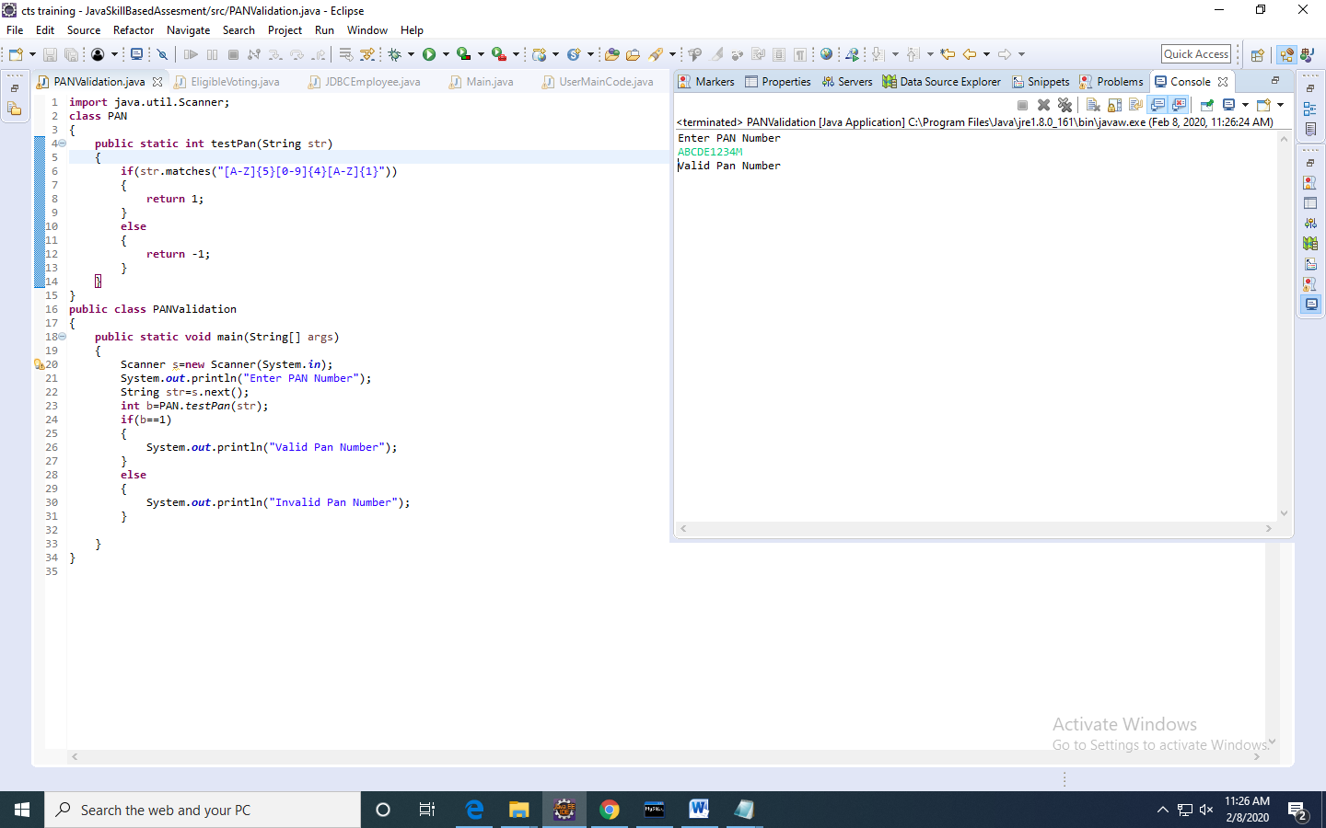

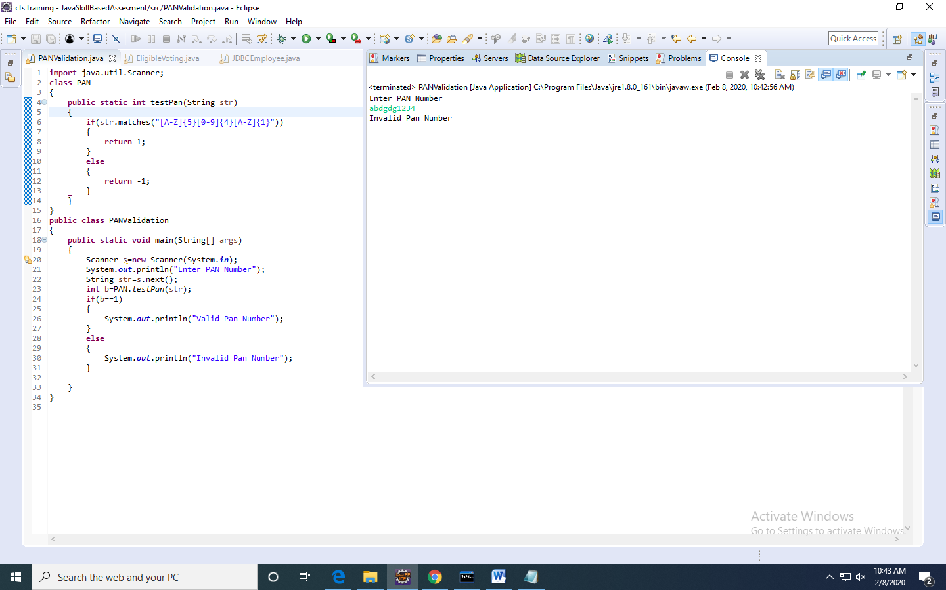

**2. Create user defined exceptions called InvalidAgeException and InsufficientAgeException, which has to be thrown when user enters a negative age and if user enters age less than 18 then it has to throw InSufficientAgeException , else has to show eligible for voting. (15 Marks)**

**import** java.util.Scanner;

**class** InvalidAgeException **extends** Exception{

**public** InvalidAgeException()

{

**super**("Age is Negative");

}

}

**class** InsufficientAgeException **extends** Exception{

**public** InsufficientAgeException()

{

**super**("Age is LessThan 18");

}

}

**class** Voting {

**public** **void** testAge(**int** age) **throws** InsufficientAgeException,InvalidAgeException

{

**if**(age>0 && age<18)

**throw** **new** InsufficientAgeException();

**else** **if**(age<0)

**throw** **new** InvalidAgeException();

**else**

System.***out***.println("eligible for voting");

}

}

**public** **class** EligibleVoting {

**public** **static** **void** main(String[] args) {

**int** age;

Scanner s=**new** Scanner(System.***in***);

System.***out***.println("Enter the age");

age=s.nextInt();

Voting v=**new** Voting();

**try**

{

v.testAge(age);

}

**catch**(InsufficientAgeException e)

{

System.***out***.println(e);

}

**catch**(InvalidAgeException e)

{

System.***out***.println(e);

}

}

}

**Output 1:**

Enter the age

20

eligible for voting

**Output 2:**

Enter the age

-1

InvalidAgeException: Age is Negative

**Output 3:**

Enter the age

5

InsufficientAgeException: Age is LessThan 18

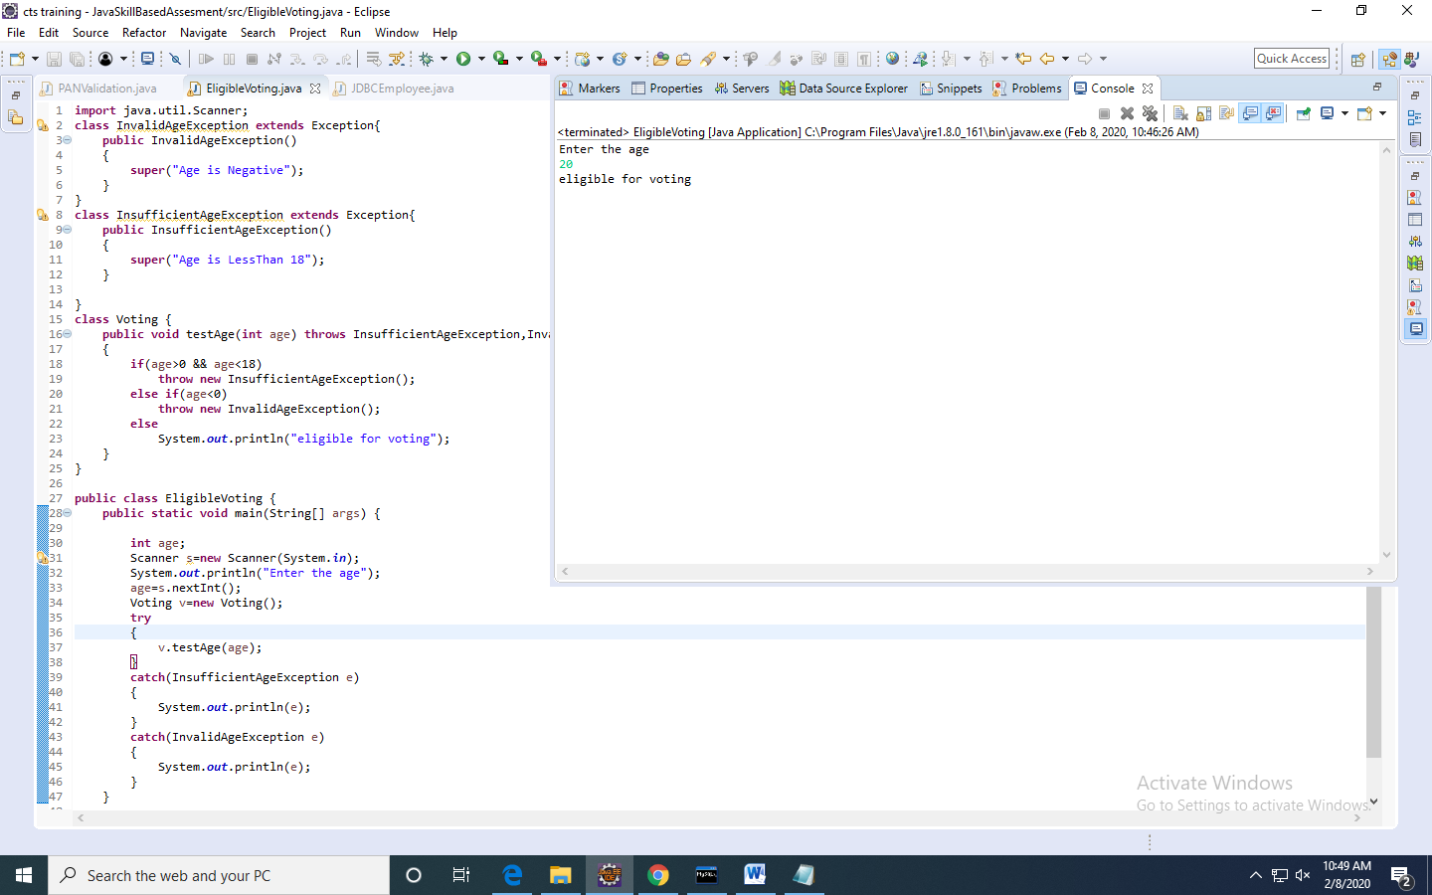

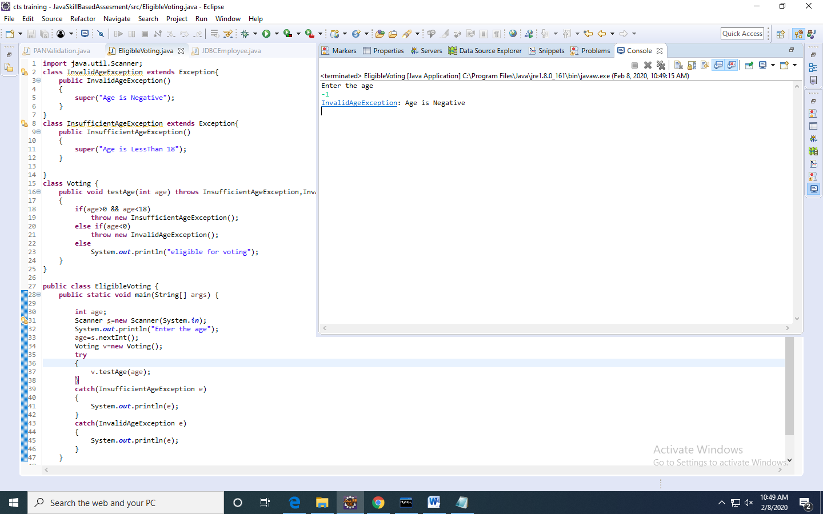

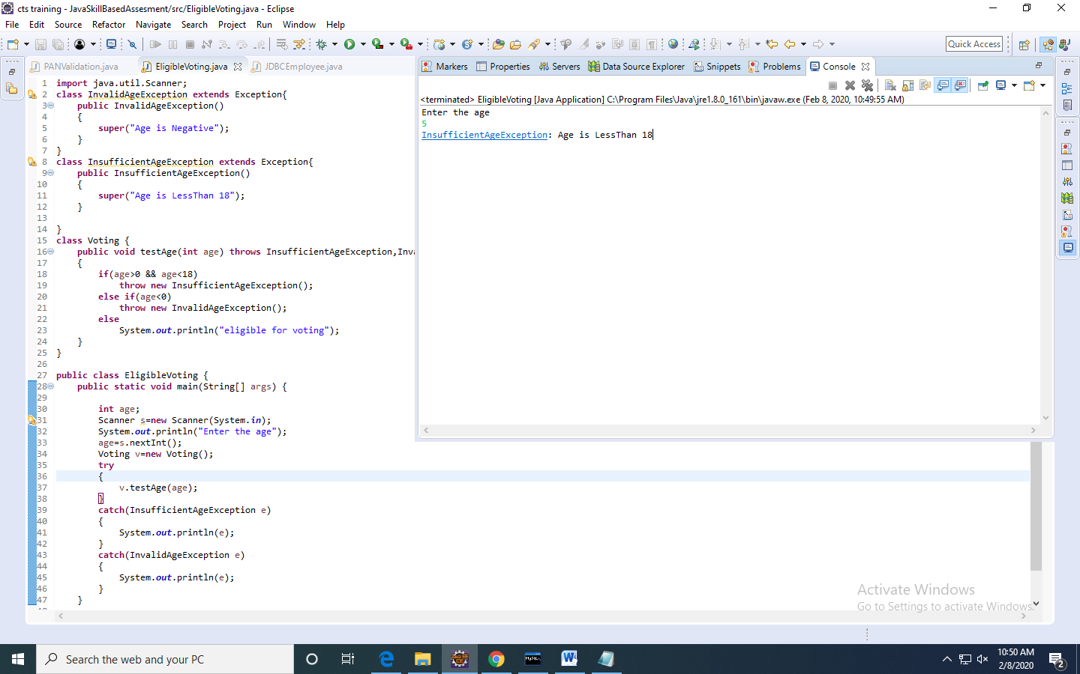

**3. Write a java program to read student objects in a ArrayList and display the student result based on the condition that max>=80, distinction, between 60 and 79 as First class, between 50 and 50 as Second class, else fail, and display only students who are passed. (25 Marks)**

**Note; Test the pass condition by using Java8 Predicate, find the class by using Function and display the results using Consumer predefined interfaces.**

**import** java.util.ArrayList;

**import** java.util.function.Consumer;

**import** java.util.function.Function;

**import** java.util.function.Predicate;

**class** Student

{

String name;

**int** marks;

**public** Student(String name, **int** marks) {

**super**();

**this**.name = name;

**this**.marks = marks;

}

}

**public** **class** PassStudentDetails

{

**public** **static** **void** main(String args[])

{

ArrayList<Student> al=**new** ArrayList<Student>();

Student s1=**new** Student("janu",90);

Student s2=**new** Student("jahnavi",79);

Student s3=**new** Student("mjanu",45);

Student s4=**new** Student("janum",20);

al.add(s1);

al.add(s2);

al.add(s3);

al.add(s4);

System.***out***.println("The Passed Students are:");

Predicate<Student>p=s->s.marks>=40;

Function<Student,String>f=s->

{

**int** m=s.marks;

**if**(m>=80)

**return** "Distinction";

**else** **if**(m>=60 && m<=79)

**return** "First Class";

**else** **if**(m>=40 && m<=50)

**return** "Second Class";

**else**

**return** "fail";

};

Consumer<Student>c=s->

{

System.***out***.print(s.name+" ");

System.***out***.println(f.apply(s));

};

**for**(Student s:al)

{

**if**(p.test(s))

{

c.accept(s);

}

}

}

}

**Output :**

The Passed Students are:

janu Distinction

jahnavi First Class

mjanu Second Class

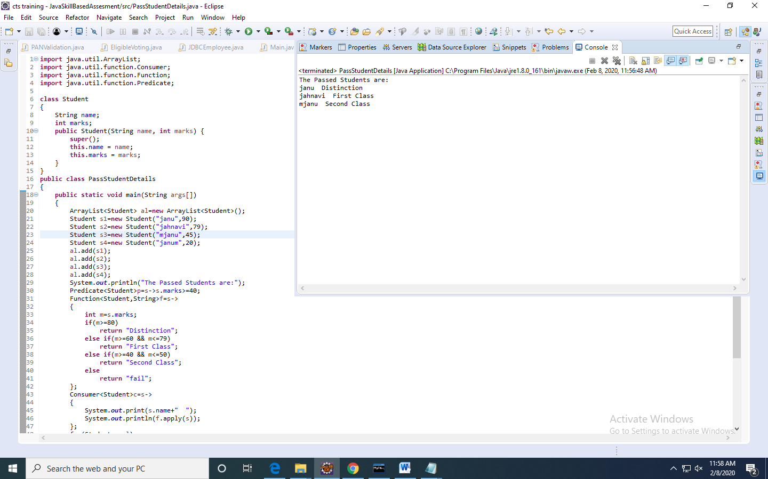

**4. Write a program that performs the following actions:**

**1. Read 2n integers as input & a set operator (of type char).**

**2. Create two arraylists to store n elements in each arraylist.**

**3. Write a function performSetOperations which accepts these two arraylist and the set operator as input.**

**4. The function would perform the following set operations:.**

**'+' for SET-UNION**

**'*' for SET-INTERSECTION**

**'-' for SET-DIFFERENCE**

**5. Return the resultant arraylist.**

**Include a class UserMainCode with the static method performSetOperations which accepts two arraylist and returns an arraylist.**

**Create a Class Main which would be used to read 2n+1 integers and call the static method present in UserMainCode. (25 Marks)**

**import** java.util.*;

**import** java.util.ArrayList;

**import** java.util.Scanner;

**public** **class** Main

{

**public** **static** **void** main(String[] args)

{

Scanner s= **new** Scanner(System.***in***);

System.***out***.println("Enter an Integer");

**int** n = Integer.*parseInt*(s.nextLine());

ArrayList<Integer> a1 = **new** ArrayList<Integer>();

ArrayList<Integer> a2 = **new** ArrayList<Integer>();

System.***out***.println("Enter ArrayList1 Values");

**for**(**int** i=0;i<n;i++)

a1.add(Integer.*parseInt*(s.nextLine()));

System.***out***.println("Enter ArrayList2 Values");

**for**(**int** i=0;i<n;i++)

a2.add(Integer.*parseInt*(s.nextLine()));

System.***out***.println("Enter Character");

**char** c = s.nextLine().charAt(0);

System.***out***.println(UserMainCode.*performSetOperations*(a1,a2,c));

}

}

**import** java.util.*;

**import** java.util.ArrayList;

**public** **class** UserMainCode

{

**public** **static** ArrayList<Integer> performSetOperations(ArrayList<Integer> a1,ArrayList<Integer> a2, **char** c)

{

ArrayList<Integer> a3= **new** ArrayList<Integer>();

**int** k = 0;

**switch** (c)

{

**case** '+':

a1.removeAll(a2);

a1.addAll(a2);

a3 = a1;

**break**;

**case** '*':

a1.retainAll(a2);

a3 = a1;

**break**;

**case** '-':

**for** (**int** i = 0; i < a1.size(); i++)

{

k = 0;

**for** (**int** j = 0; j < a2.size(); j++)

{

**if** (a1.get(i) == a2.get(j))

k = 1;

}

**if** (k == 0)

a3.add(a1.get(i));

}

**break**;

}

**return** a3;

}

}

**Output 1:**

Enter an Integer

3

Enter ArrayList1 Values

1

2

3

Enter ArrayList2 Values

4

5

6

Enter Character

+

[1, 2, 3, 4, 5, 6]

**Output 2:**

Enter an Integer

3

Enter ArrayList1 Values

10

20

30

Enter ArrayList2 Values

10

20

40

Enter Character

-

[30]

**Output 3:**

Enter an Integer

3

Enter ArrayList1 Values

10

20

30

Enter ArrayList2 Values

10

20

40

Enter Character

*

[10, 20]

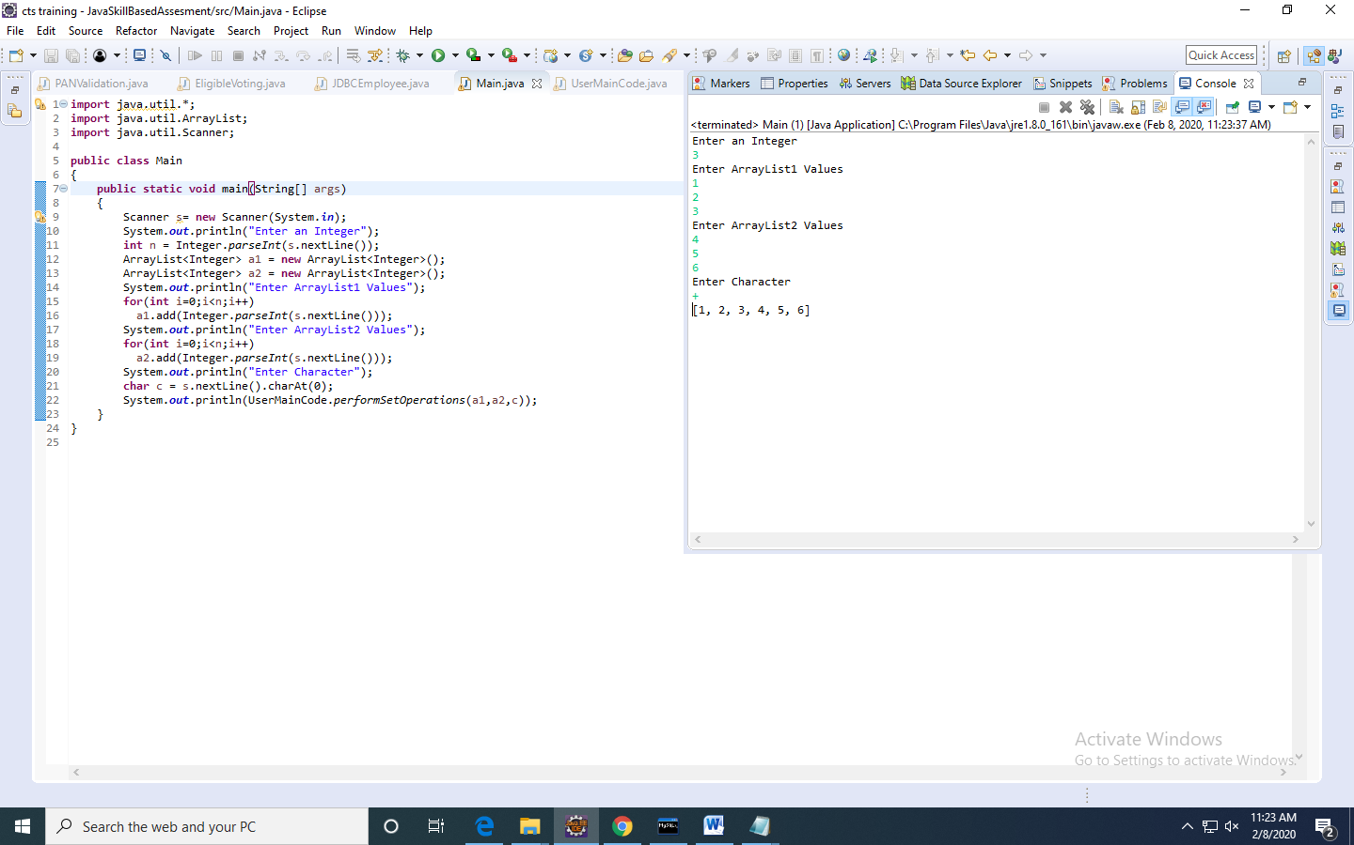

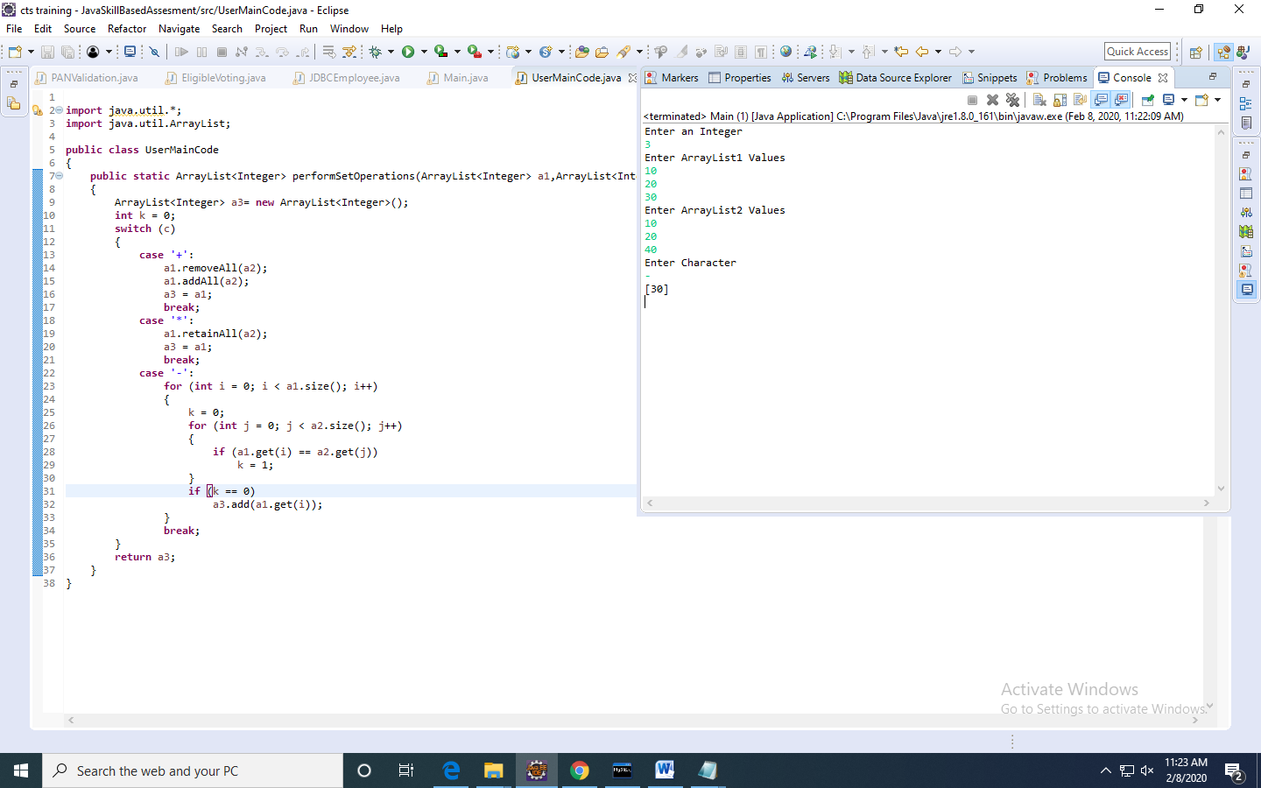

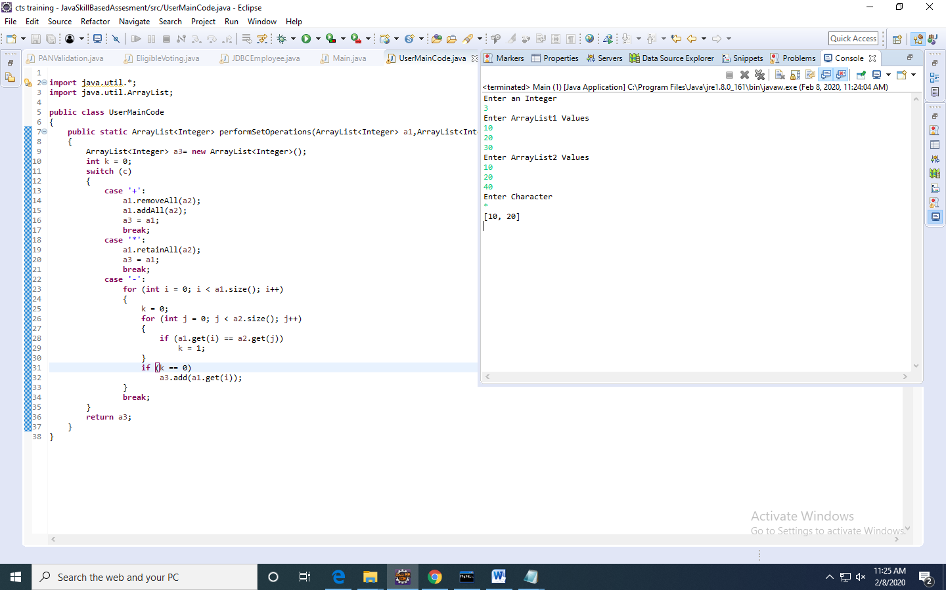

5. Write a JDBC program to read Employee(name,id,dept,desg,company,emailed) from the user and insert into mysql table called employee.(25 Marks)

**import** java.sql.Connection;

**import** java.sql.DriverManager;

**import** java.sql.PreparedStatement;

**import** java.sql.SQLException;

**import** java.util.Scanner;

**public** **class** JDBCEmployee {

**public** **static** **void** main(String args[])**throws** ClassNotFoundException,SQLException

{

DriverManager.*registerDriver*(**new** com.mysql.cj.jdbc.Driver());

Connection connection=DriverManager.*getConnection*

("jdbc:mysql://localhost:3306/cts","root","root");

String query="insert into employee values(?,?,?,?,?,?)";

PreparedStatement pst=connection.prepareStatement(query);

Scanner sc=**new** Scanner(System.***in***);

System.***out***.println("Enter Employee Name");

String name=sc.next();

System.***out***.println("Enter Employee Id");

**int** id=sc.nextInt();

System.***out***.println("Enter Employee Department");

String dept=sc.next();

System.***out***.println("Enter Employee Designation");

String desg=sc.next();

System.***out***.println("Enter Employee Company");

String company=sc.next();

System.***out***.println("Enter Employee EmailId");

String emailid=sc.next();

pst.setString(1,name);

pst.setInt(2,id);

pst.setString(3,dept);

pst.setString(4,desg);

pst.setString(5,company);

pst.setString(6,emailid);

**int** x=pst.executeUpdate();

System.***out***.println((x +"Record Inserted Successfully"));

}

}

**Output:**

Enter Employee Name

janu

Enter Employee Id

343

Enter Employee Department

software

Enter Employee Designation

analyst

Enter Employee Company

cognizant

Enter Employee EmailId

jahnavi.guruju@cognizant.com

1Record Inserted Successfully

mysql> select * from employee;

+---------------+--------+----------+----------------+-----------+------------------------------+

| name | id | dept | desg | company | emailid |

+---------------+--------+----------+----------------+-----------+------------------------------+

| jahnavi | 101 | java | analyst | cts | guruju@gmail.com |

| jahnaviguruju | 844343 | software | programanalyst | cognizant | guruju.jahnavi@cognizant.com |

| janu | 343 | software | analyst | cognizant | jahnavi.guruju@cognizant.com |

+---------------+--------+----------+----------------+-----------+------------------------------+

3 rows in set (0.00 sec)

